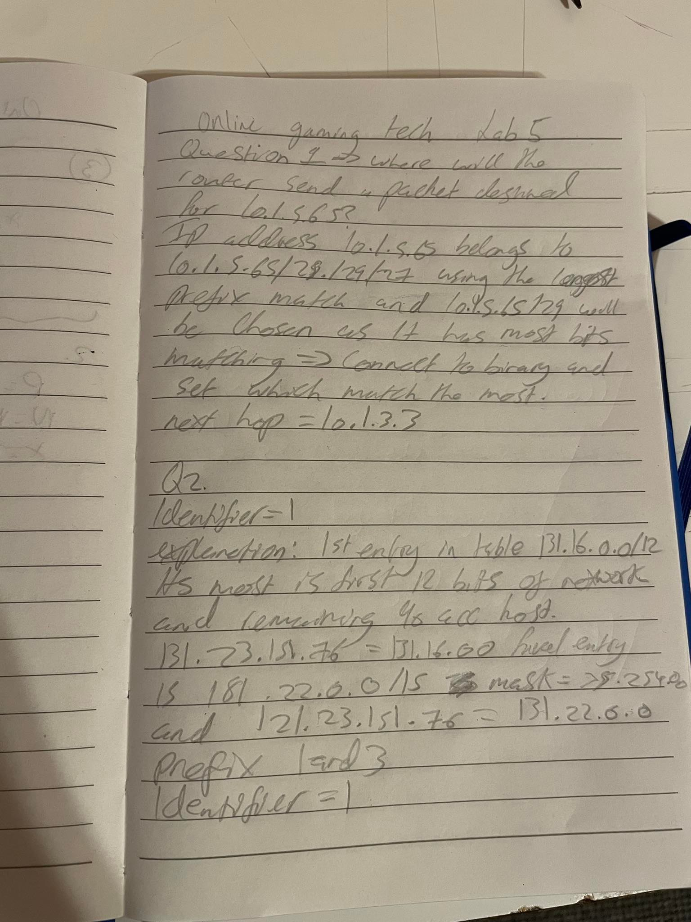

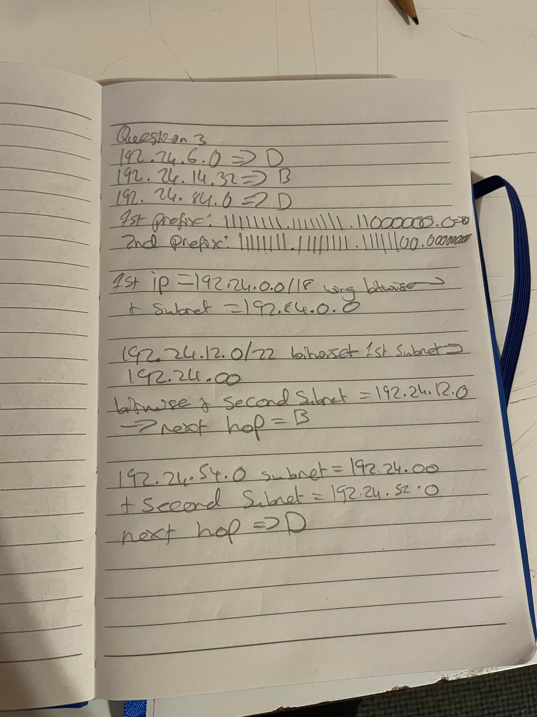

Q4

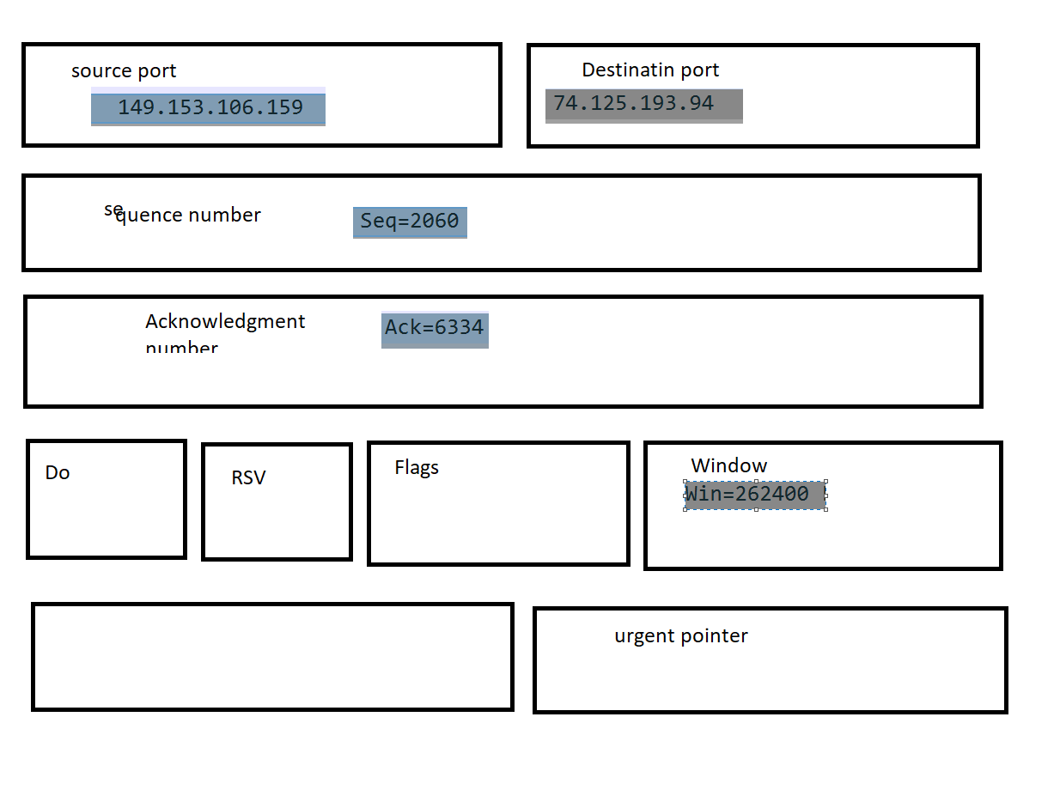

Source port =source address

Destination port = destination address

Squence number = number of bites being sent to the destinatino

Acknowledgement number = number of next bites the reciever expects to receive

Window = mitigate problems woth clients and servers trying to share segments of data that are to large or to small

Q5

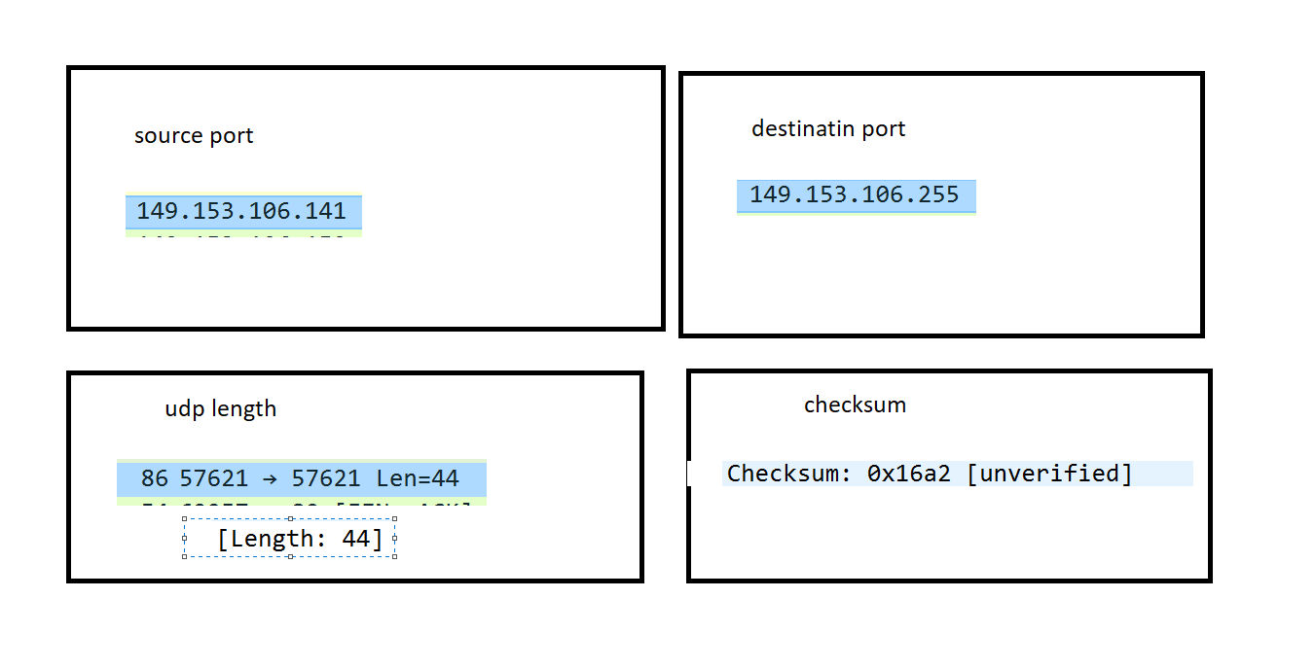

Source port = source address

Destinatin port =destination address

Udp length = number of bytes comprising the udp header and udp payload data

Checksum = correct digits in a piece of stored or transmitted digital data, against which later comparisons can be made to detect errors in the data.